**ROCK PAPER SCISSOR**

**A Mini Project in C**

**Academic Year: 2021-22 ODD SEMESTER**

**Department: B.Tech Computer science and Engineering with specialization in Artificial Intelligence and Machine Learning.**

**Semester: 1**

**Course Code: 18CSS101J**

**Course Title: Programming for Problem Submitted by:**

**Rayala Manogna (RA2111026010227)**

**Keshavi Sharma (RA2111026010234)**

**Sri Vyshnav (RA2111026010235)**

**Under the Guidance of**

**Lakshminarayana R Sir**

**(Associate Professor, NWC)**

**DEPARTMENT OF COMPUTING**

**COLLEGE OF ENGINEERING AND TECHNOLOGY**

# AIM

To create a game that allows users to play STONE PAPER

SCISSOR with the computer in a neat and convenient manner.

# ABSTRACT

Stone Paper Scissors is a childhood favorite of many, and works similarly on the computer to how it does in person. The player chooses to throw the stone, paper, or scissors, and the computer plays the same on the other side. There is an immediate winner, and the game challenges the player to try to think strategically to try to outsmart the computer.

# ALGORITHM

STEP 1: Input V1

STEP 2:Input V2

STEP 3: If (v1 = stone) then

STEP 4: If (v2 = stone) goto draw

STEP 5: If (v2 = paper) goto lost

STEP 6: If (v2 = scissors) goto win

STEP 7: If (v1 = paper) then

STEP 8: If (v2 = stone) goto win

STEP 9:If (v2 = paper) goto draw

STEP 10:If (v2 = scissors) goto lost

STEP 11: If (v1 = scissors) then

STEP 12: If (v2 = stone) goto lost

STEP 13: If (v2 = paper) goto win

STEP 14: If (v2 = scissors) goto draw

STEP 15: // if we got here, something was wrong with input values

STEP 16: print error message; goto exit

STEP 17:draw: print draw message; goto exit

STEP 18: Lost: print lost message; goto exit

STEP 19: win: print win message; goto exit

STEP 20: exit: exit the program

SOURCE CODE

// C program for the above approach

#include <math.h>

#include <stdio.h>

#include <stdlib.h>

#include <time.h>

// Function to implement the game int game(char you, char computer)

{

// If both the user and computer // has chose the same thing if (you == computer) return -1;

// If user's choice is stone and // computer's choice is paper if (you == 's' && computer == 'p') return 0;

// If user's choice is paper and // computer's choice is stone else if (you == 'p' && computer == 's') return 1;

// If user's choice is stone and // computer's choice is scissor if (you == 's' && computer == 'z') return 1;

// If user's choice is scissor and // computer's choice is stone else if (you == 'z' && computer == 's') return 0;

// If user's choice is paper and // computer's choice is scissor if (you == 'p' && computer == 'z') return 0;

// If user's choice is scissor and // computer's choice is paper else if (you == 'z' && computer == 'p') return 1;

}

// Driver Code int main()

{

// Stores the random number

int n; char you, computer, result; // Chooses the random number

// every time srand(time(NULL)); // Make the random number less // than 100, divided it by 100 n = rand() % 100;

// Using simple probability 100 is

// roughly divided among stone,

// paper, and scissor if (n < 33)

// s is denoting Stone computer = 's'; else if (n > 33 && n < 66) // p is denoting Paper computer = 'p'; // z is denoting Scissor else computer = 'z';

printf("\n\n\n\n\t\t\t\tEnter s for STONE, p for PAPER and z for

SCISSOR\n\t\t\t\t\t\t\t"); // input from the user scanf("%c", &you);

// Function Call to play the game result = game(you, computer); if (result == -1) { printf("\n\n\t\t\t\tGame Draw!\n"); } else if (result == 1) { printf("\n\n\t\t\t\tWow! You have won the game!\n");

}

else { printf("\n\n\t\t\t\tOh! You have lost the game!\n");

}

printf("\t\t\t\tYOu choose : %c and Computer choose : %c\n",you, computer); return 0;

}

# FLOWCHART

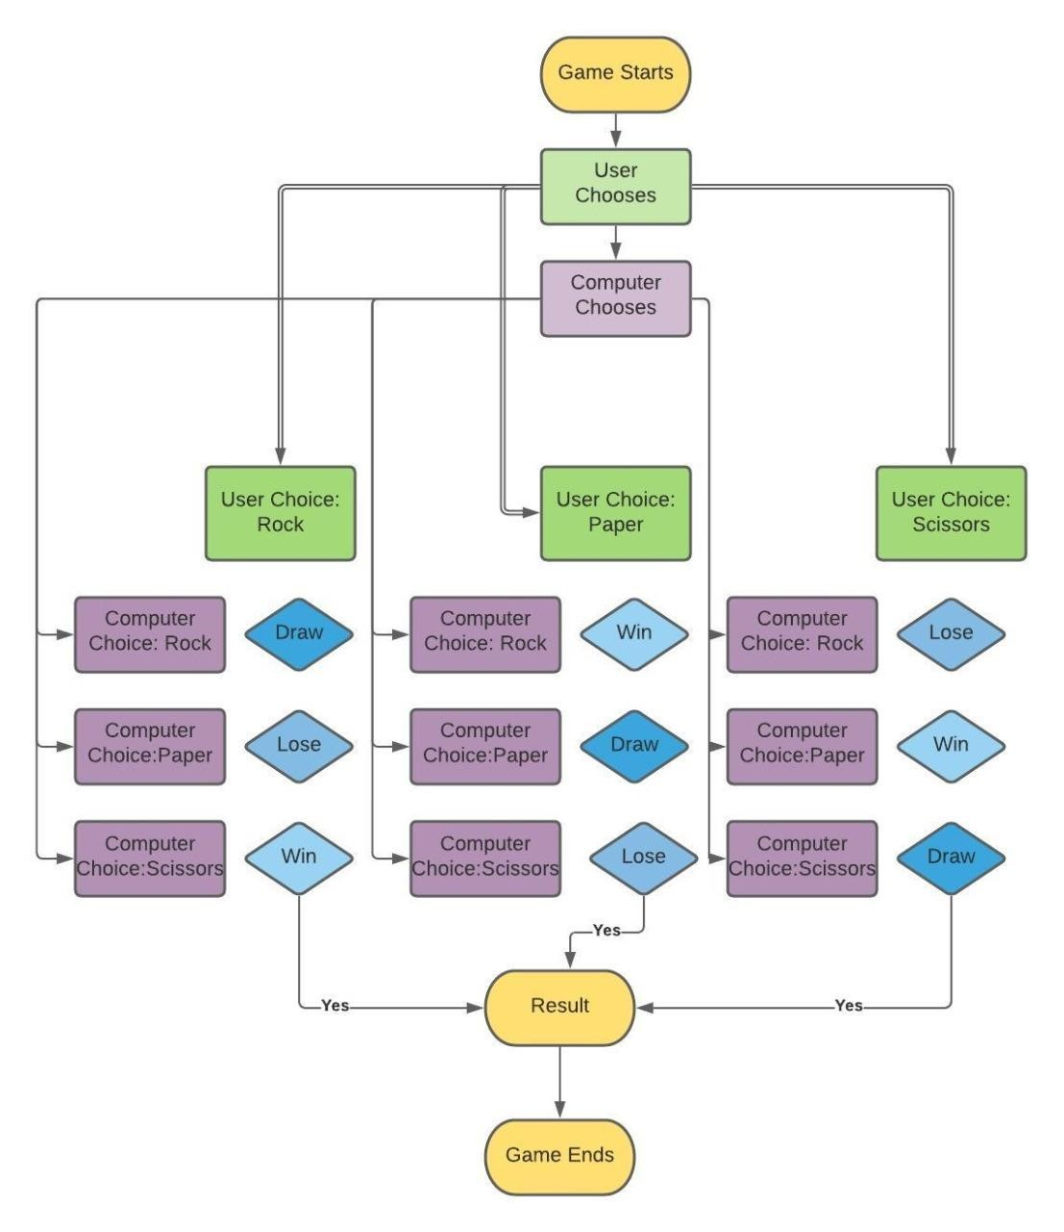

OUTPUT

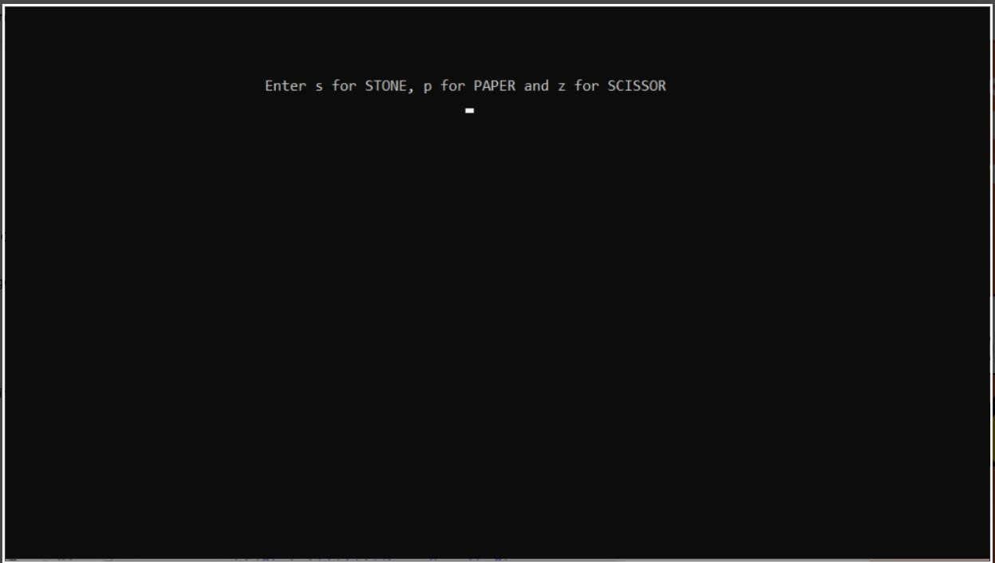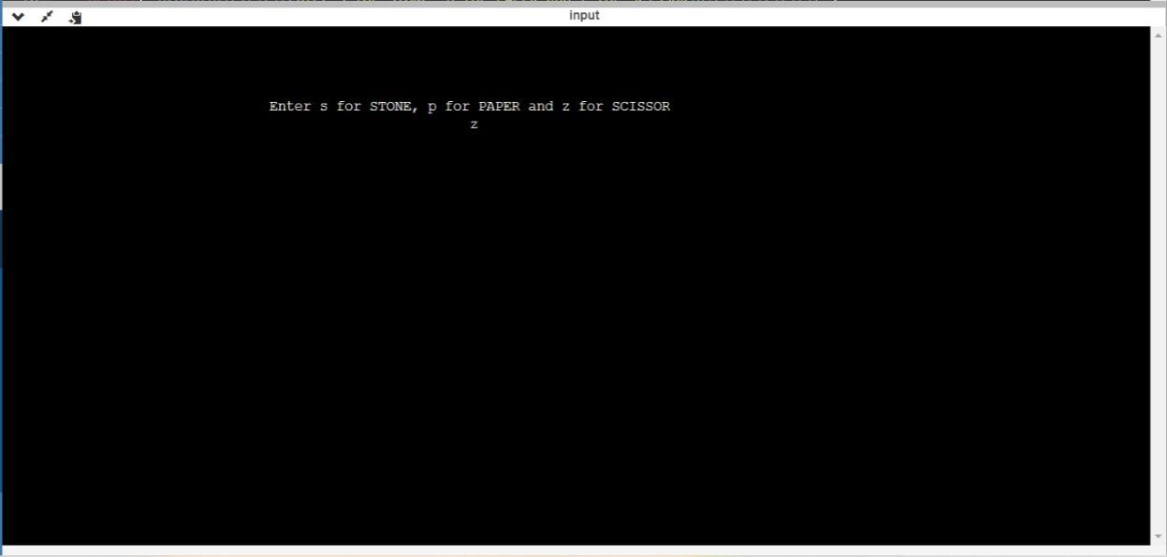

# RESULT

Our project Stone Paper Scissor provides easy access to a formatted game. Our project has succeeded in managing the data and providing the best output.

# CONCLUSION

Stone Paper Scissors has been a hit with all age groups tested. It is a classic game that is enhanced through picture animations. However, in the future, these images could be programmed to look nicer rather than showing as a plain figure window. Also, different versions of the game could be added so the user could choose which version they would like to play.

Report by:

Keshavi Sharma

RA2111026010234